Sprint Plan 1

**Product:** SquadUp

**Team:** The Big Ballers

**Completion date:** July 9th

**Revision number:** 1.0

**Revision date:** 7/2/2018

**Goal:**

To build the basic features (creating accounts, web frameworks, the guest features) of the application.

**Tasks for user stories:**  User Story 1: As a developer, I want to set up our development environment so that we have a basic starting point. Story Points: 13.

* + Task 1: setup node.js server using express.
    - **Hours estimated:** 1
  + Task 2: setup mLab
    - **Hours estimated:** 1
  + Task 3: setup our mongo database using mLab.
    - **Hours estimated:** 1
  + Task 4: Create database schema
    - **Hours estimated:** 3
  + Task 5: Link google user account with database
    - **Hours estimated:** 3
  + Task 6: Research how to create REACT web application
    - **Hours estimated:** 2
  + Task 7: Mockup design for frontend
    - **Hours estimated**: 3
  + Task 8: Create a front end page to host log in
    - **Hours estimated:** 1

**Total Time for User Story**: 15

User Story 2: As a user, I want to be able to create an account so that I can manage my profile. Story Points: 8.

* + Task 1: Create a home page.
    - **Hours estimated**: 1
  + Task 2: Create an account holder page.
    - **Hours estimated**: 1
  + Task 3: Create Park Finder page:
    - **Hours estimated**: 1
  + Task 4: Create an event page/form.
    - **Hours estimated**: 1
  + Task 5: Create an add park page/form
    - **Hours estimated**: 1

**Total Time for User Story**: 5 hours

* User Story 3: As a user, I want to search for parks in my area so that I can find a park to go to. Story Points: 5.
  + Task 1: Use the google maps API to display parks.
    - **Hours estimated**: 2
  + Task 2: Test search functionality of the google maps API.
    - **Hours estimated**: 1

**Total Time for User Story**: 3 hours



**Team roles:**

* Zahir Yahya: Backend Developer
* Sean Woods: Frontend, Backend Developer
* Chuangbo Tong: Web page mockups, Frontend Developer
* Shyaan Khan: Web page mockups
* Collin Fulcher: Frontend Developer
* Tyler Frick: Backend Developer

**Initial task assignment:**

* Zahir Yahya:
  + User story 1
  + Link the user google account with DB.
  + Set up the database, MongoDB
  + Set up Mlab
  + Create a Database Schema
  + Set up node.js and express with server.
* Sean Woods:
  + User Story 1,2,3
  + Researching how to create a REACT web application.
  + Create an account holder page
  + Create Park Finder page
  + Create an event page/form
  + Test search functionality of the google maps API.
* Chuangbo Tong:
  + User story 1,2,3
  + Mockup design
  + Create an add park page/form
  + Use google maps API to search for parks
  + Make an API call to google to get metrics on the parks for the hours it is busy and estimated how many people are there.
* Shyaan Khan:
  + User story 1
  + Mock up design for the front end.
  + Create a Database Schema
* Collin Fulcher:
  + User story 1, 2
  + Create a homepage
  + Create a front end page to host the account log in.
* Tyler Frick:
  + User story 2
  + Set up node.js and express with server.

**Initial burnup chart:**

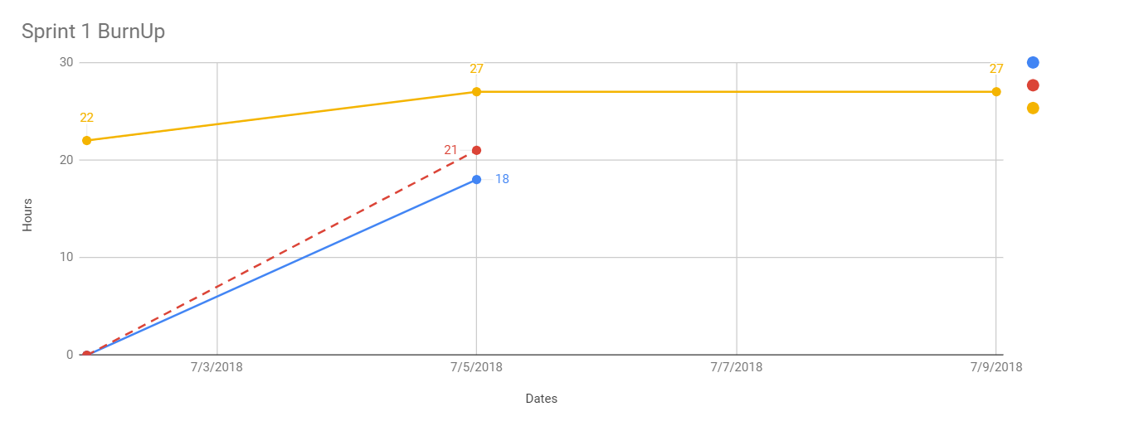



**Initial scrum board:**

https://trello.com/b/5uzWWJz7/squadup-scrum-board



**Scrum times:**

Monday: After TA meeting: 1:00 PM

Wednesday: After class: 12:30 PM

Thursday: After TA meeting 1:00 PM